**LAB WORK**

**OBJECT**

Find the genetic map positions of the genes *w* (white eyes),

*m* (miniature wings), and *f* (forked bristles) on the X chromosome

(also denoted as chromosome 1) of *Drosophila melanogaster*.

**THEORY**

# FlyBase:

[FlyBase](http://www.flybase.org/) is an online [bioinformatics](https://en.wikipedia.org/wiki/Bioinformatics) [database](https://en.wikipedia.org/wiki/Database) and the primary repository of genetic and molecular data for the insect family *[Drosophilidae](https://en.wikipedia.org/wiki/Drosophilidae" \o "Drosophilidae)*. For the most extensively studied species and [model organism](https://en.wikipedia.org/wiki/Model_organism), [*Drosophila melanogaster*](https://en.wikipedia.org/wiki/Drosophila_melanogaster), a wide range of data are presented in different formats. Information in FlyBase originates from a variety of sources ranging from large-scale genome projects to the primary research literature. These data types include mutant [phenotypes](https://en.wikipedia.org/wiki/Phenotypes), molecular characterization of mutant [alleles](https://en.wikipedia.org/wiki/Alleles) and other deviations, cytological maps, [wild-type](https://en.wikipedia.org/wiki/Wild-type) expression patterns, anatomical images, transgenic constructs and insertions, sequence-level gene models and molecular classification of gene product functions. Query tools allow navigation of FlyBase through DNA or protein sequence, by gene or mutant name, or through terms from the several ontologies used to capture functional, phenotypic, and anatomical data. The database offers several different query tools in order to provide efficient access to the data available and facilitate the discovery of significant relationships within the database. Links between FlyBase and external databases, such as [BDGP](http://www.fruitfly.org/) or [modENCODE](http://www.modencode.org/), provide opportunity for further exploration into other [model organism databases](https://en.wikipedia.org/wiki/Model_organism_databases) and other resources of biological and molecular information.

**Drosophila Melanogaster:**

Drosophila melanogaster is a species of fly (the taxonomic order Diptera) in the family Drosophilidae. The species is known generally as the common fruit fly (though inaccurately or vinegar fly. Starting with Charles W. Woodworth's proposal of the use of this species as a model organism, D. melanogaster continues to be widely used for biological research in genetics, physiology, microbial pathogenesis, and life history evolution. As of 2017, eight Nobel prizes had been awarded for research using Drosophila.D. melanogaster is typically used in research because it can be readily reared in the laboratory, has only four pairs of chromosomes, breeds quickly, and lays many eggs. Its geographic range includes all continents, including islands. D. melanogaster is a common pest in homes, restaurants, and other places where food is served.

**PROCEDURE:**

At the web site, click on Genomes and Maps, then on Genome Project, and finally on

Genomic Biology. Then under Genome resources, click on Insects. From there, open

the page on *Drosophila melanogaster* and then under Sequencing Centers in the

sidebar, click on FlyBase, which is the database for genomic information about *Drosophila*.

On the FlyBase main page, search for each of the three genes to obtain the genetic

and cytological locations.

**OBSERVATION:**

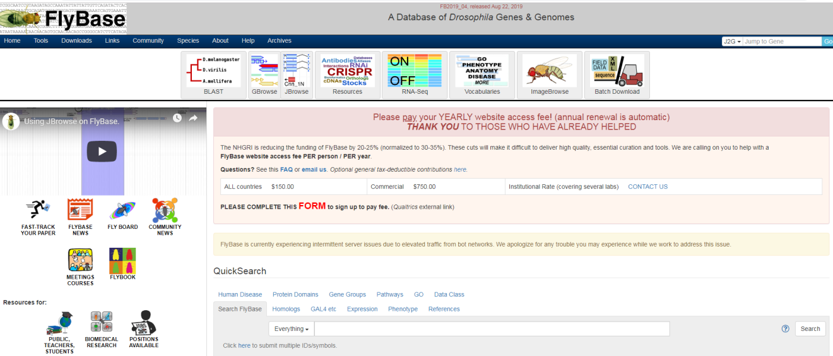

**CytoGenetic Location:**

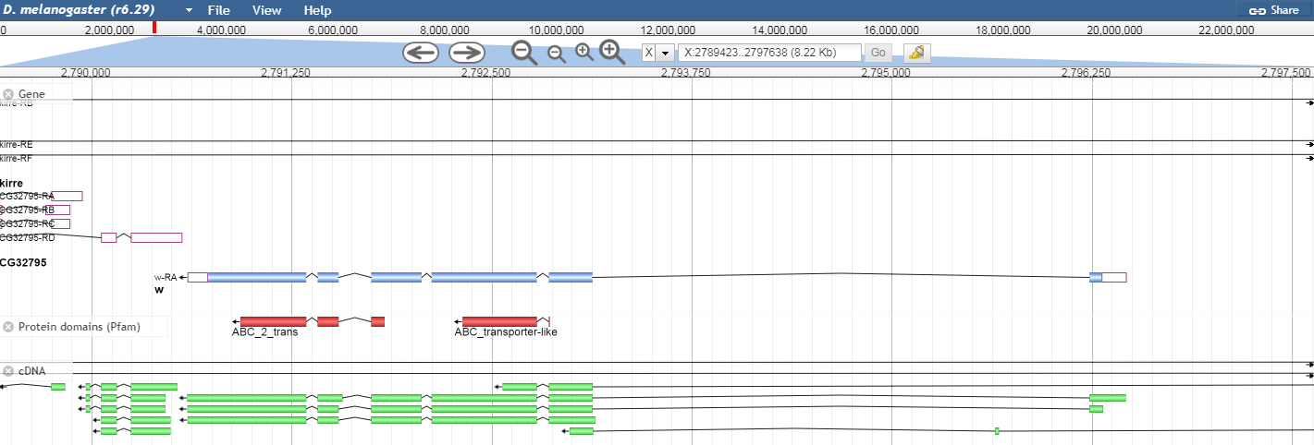

**Genomic Location:**

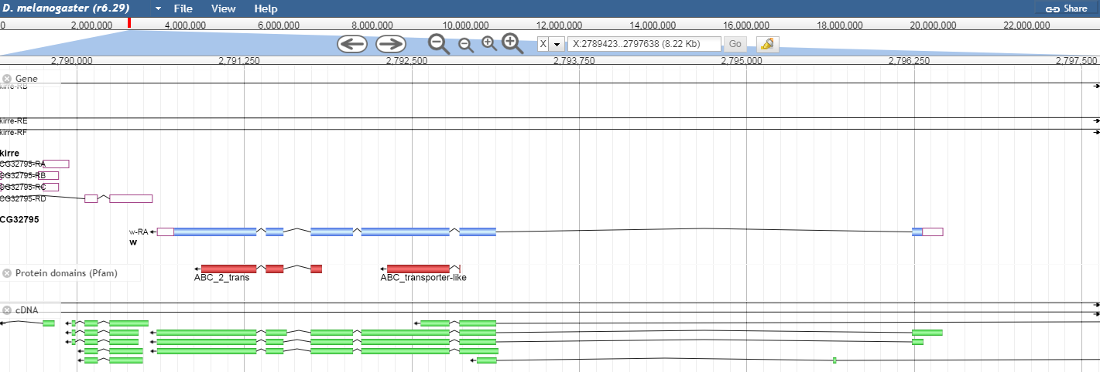

**RESULT:**

Drosophila melanogaster is a species of fly in the family Drosophilidae. The species is known generally as the common fruit fly. D. melanogaster continues to be widely used for biological research in genetics, physiology, microbial pathogenesis, and life history evolution.

**LAB 12**

**OBJECT**

Find the positions of these three genes on the cytogenetic map of the

X chromosome of *D. melanogaster*.

**THEORY**

# FlyBase:

[FlyBase](http://www.flybase.org/) is an online [bioinformatics](https://en.wikipedia.org/wiki/Bioinformatics) [database](https://en.wikipedia.org/wiki/Database) and the primary repository of genetic and molecular data for the insect family *[Drosophilidae](https://en.wikipedia.org/wiki/Drosophilidae" \o "Drosophilidae)*. For the most extensively studied species and [model organism](https://en.wikipedia.org/wiki/Model_organism), [*Drosophila melanogaster*](https://en.wikipedia.org/wiki/Drosophila_melanogaster), a wide range of data are presented in different formats. Information in FlyBase originates from a variety of sources ranging from large-scale genome projects to the primary research literature. These data types include mutant [phenotypes](https://en.wikipedia.org/wiki/Phenotypes), molecular characterization of mutant [alleles](https://en.wikipedia.org/wiki/Alleles) and other deviations, cytological maps, [wild-type](https://en.wikipedia.org/wiki/Wild-type) expression patterns, anatomical images, transgenic constructs and insertions, sequence-level gene models and molecular classification of gene product functions. Query tools allow navigation of FlyBase through DNA or protein sequence, by gene or mutant name, or through terms from the several ontologies used to capture functional, phenotypic, and anatomical data. The database offers several different query tools in order to provide efficient access to the data available and facilitate the discovery of significant relationships within the database. Links between FlyBase and external databases, such as [BDGP](http://www.fruitfly.org/) or [modENCODE](http://www.modencode.org/), provide opportunity for further exploration into other [model organism databases](https://en.wikipedia.org/wiki/Model_organism_databases) and other resources of biological and molecular information.

**Drosophila Melanogaster:**

Drosophila melanogaster is a species of fly (the taxonomic order Diptera) in the family Drosophilidae. The species is known generally as the common fruit fly (though inaccurately or vinegar fly. Starting with Charles W. Woodworth's proposal of the use of this species as a model organism, D. melanogaster continues to be widely used for biological research in genetics, physiology, microbial pathogenesis, and life history evolution. As of 2017, eight Nobel prizes had been awarded for research using Drosophila.D. melanogaster is typically used in research because it can be readily reared in the laboratory, has only four pairs of chromosomes, breeds quickly, and lays many eggs. Its geographic range includes all continents, including islands. D. melanogaster is a common pest in homes, restaurants, and other places where food is served.

**PROCEDURE:**

At the web site, click on Genomes and Maps, then on Genome Project, and finally on

Genomic Biology. Then under Genome resources, click on Insects. From there, open

the page on *Drosophila melanogaster* and then under Sequencing Centers in the

sidebar, click on FlyBase, which is the database for genomic information about *Drosophila*.

On the FlyBase main page, search for each of the three genes to obtain the genetic

and cytological locations.

**OBSERVATION:**



**Gene w:**

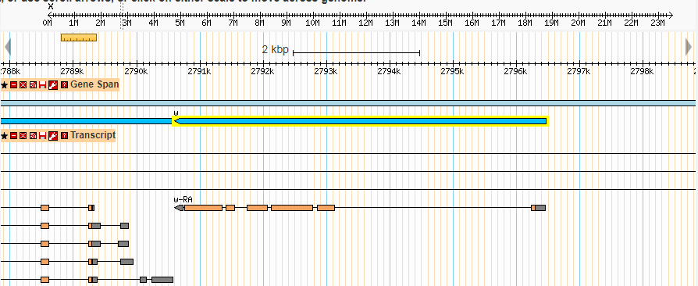

**Gene f:**

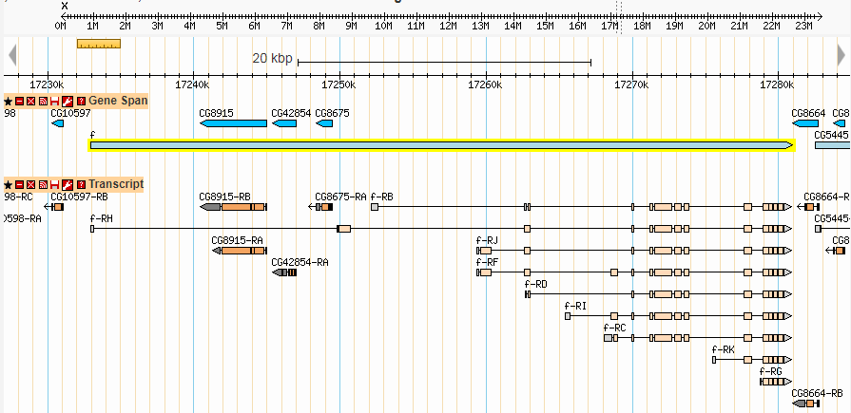

**Gene m:**

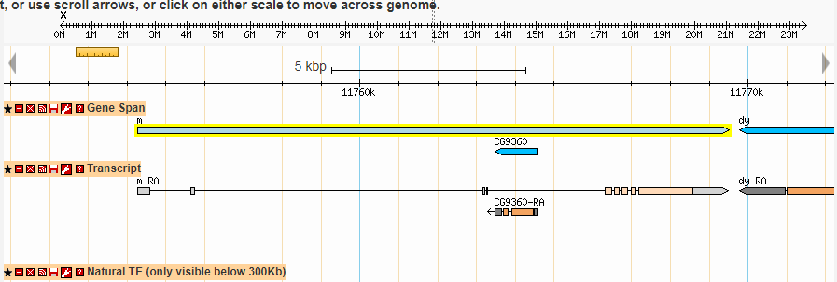

**RESULT:**

Drosophila melanogaster is a species of fly in the family Drosophilidae. The species is known generally as the common fruit fly. D. melanogaster continues to be widely used for biological research in genetics, physiology, microbial pathogenesis, and life history evolution.

**LAB 13**

**OBJECT**

Use the Map Viewer function on the web site to locate *w, m,* and *f*

on the ideogram of the X chromosome.

**THEORY**

# FlyBase:

[FlyBase](http://www.flybase.org/) is an online [bioinformatics](https://en.wikipedia.org/wiki/Bioinformatics) [database](https://en.wikipedia.org/wiki/Database) and the primary repository of genetic and molecular data for the insect family *[Drosophilidae](https://en.wikipedia.org/wiki/Drosophilidae" \o "Drosophilidae)*. For the most extensively studied species and [model organism](https://en.wikipedia.org/wiki/Model_organism), [*Drosophila melanogaster*](https://en.wikipedia.org/wiki/Drosophila_melanogaster), a wide range of data are presented in different formats. Information in FlyBase originates from a variety of sources ranging from large-scale genome projects to the primary research literature. These data types include mutant [phenotypes](https://en.wikipedia.org/wiki/Phenotypes), molecular characterization of mutant [alleles](https://en.wikipedia.org/wiki/Alleles) and other deviations, cytological maps, [wild-type](https://en.wikipedia.org/wiki/Wild-type) expression patterns, anatomical images, transgenic constructs and insertions, sequence-level gene models and molecular classification of gene product functions. Query tools allow navigation of FlyBase through DNA or protein sequence, by gene or mutant name, or through terms from the several ontologies used to capture functional, phenotypic, and anatomical data. The database offers several different query tools in order to provide efficient access to the data available and facilitate the discovery of significant relationships within the database. Links between FlyBase and external databases, such as [BDGP](http://www.fruitfly.org/) or [modENCODE](http://www.modencode.org/), provide opportunity for further exploration into other [model organism databases](https://en.wikipedia.org/wiki/Model_organism_databases) and other resources of biological and molecular information.

**Drosophila Melanogaster:**

Drosophila melanogaster is a species of fly (the taxonomic order Diptera) in the family Drosophilidae. The species is known generally as the common fruit fly (though inaccurately or vinegar fly. Starting with Charles W. Woodworth's proposal of the use of this species as a model organism, D. melanogaster continues to be widely used for biological research in genetics, physiology, microbial pathogenesis, and life history evolution. As of 2017, eight Nobel prizes had been awarded for research using Drosophila.D. melanogaster is typically used in research because it can be readily reared in the laboratory, has only four pairs of chromosomes, breeds quickly, and lays many eggs. Its geographic range includes all continents, including islands. D. melanogaster is a common pest in homes, restaurants, and other places where food is served.

**PROCEDURE:**

At the web site, click on Genomes and Maps, then on Genome Project, and finally on

Genomic Biology. Then under Genome resources, click on Insects. From there, open

the page on *Drosophila melanogaster* and then under Sequencing Centers in the

sidebar, click on FlyBase, which is the database for genomic information about *Drosophila*.

On the FlyBase main page, search for each of the three genes to obtain the genetic and cytological locations.

**OBSERVATION**

**GENE w:**

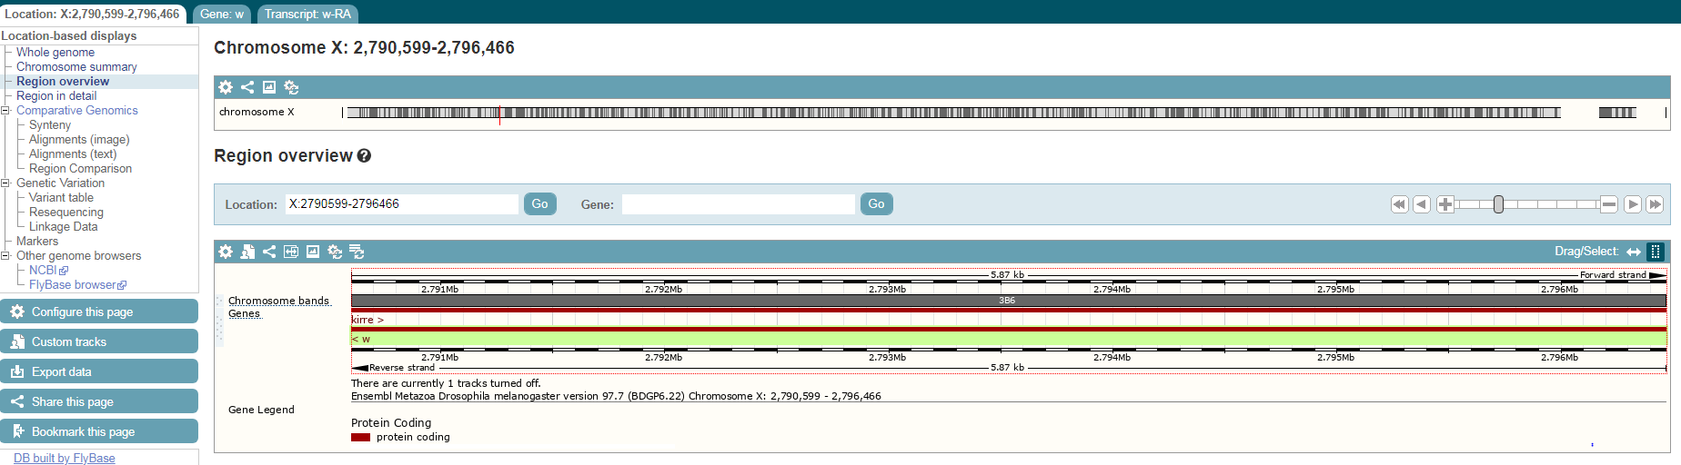

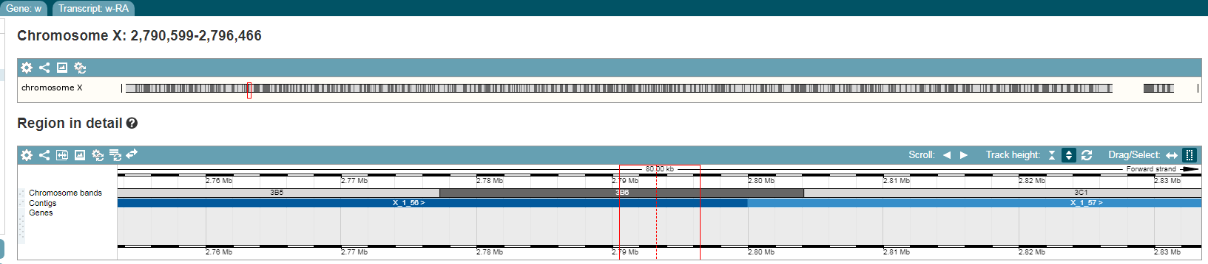

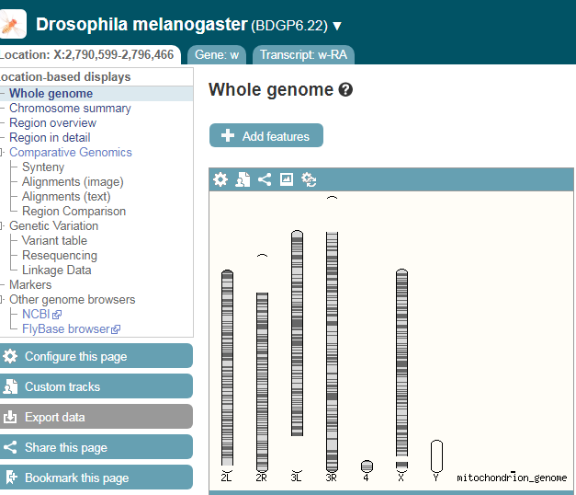

**GENE f :**

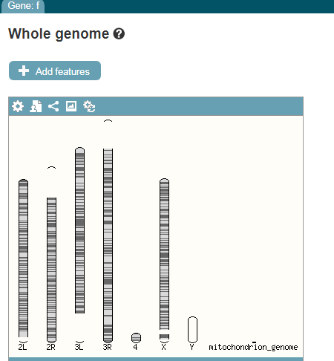

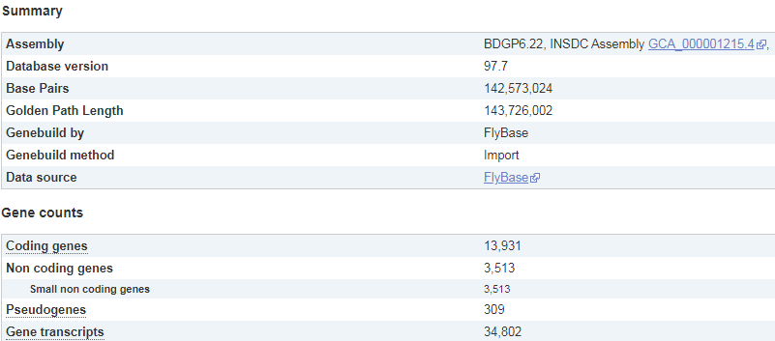

**GENE m:**

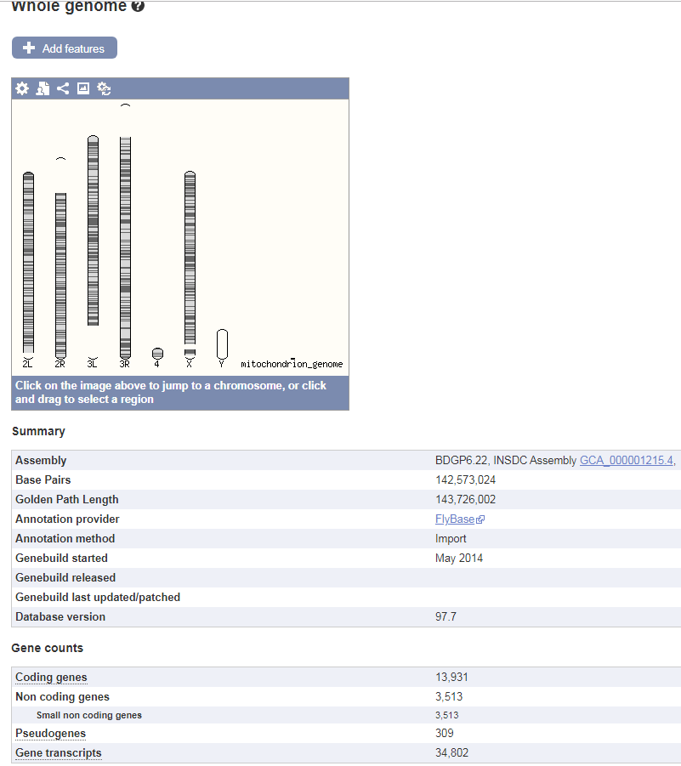

**RESULT:**

**An ideogram is a diagrammatic representation** of the karyotype that shows all of the pairs of homologous chromosomes in the nucleus. The pairs of chromosomes are lined up in order of size, so that the centromeres are aligned and the short arm is uppermost. An ideogram is a useful point of reference for analyzing mutations.

**LAB 14**

**OBJECT**

Homologous genes are genes that have been derived from a common ancestor. The *SRY* gene for sex determination in humans is located on the Y chromosome. A homologue of this gene, called *SOX3*, is located on the X chromosome.Find these two genes on the ideograms of the human sex chromosomes.

**THEORY**

**Ensembl:**

Ensembl aims to provide a centralized resource for geneticists, molecular biologists and other researchers studying the [genomes](https://en.wikipedia.org/wiki/Genome) of our own species and other [vertebrates](https://en.wikipedia.org/wiki/Vertebrate) and [model organisms](https://en.wikipedia.org/wiki/Model_organism). Ensembl is one of several well known [genome browsers](https://en.wikipedia.org/wiki/Genome_browser) for the retrieval of [genomic](https://en.wikipedia.org/wiki/Genomic) information. In the Ensembl project, sequence data are fed into the gene annotation system which creates a set of predicted gene locations and saves them in a [MySQL](https://en.wikipedia.org/wiki/MySQL) database for subsequent analysis and display. Ensembl makes these data freely accessible to the world research community. All the data and code produced by the Ensembl project is available to download, and there is also a publicly accessible database server allowing remote access. In addition, the Ensembl website provides computer-generated visual displays of much of the data.

**PROCEDURE:**

* . Go to visit the site
* <https://www.ensembl.org/>
* Then select the Homo Sapiens in the database.
* Enter the id SRY in the searchbar.
* Then Select any id.
* After open the file click Region Detail in the side bar.
* Then click the Whole Genome.
* Ideogram is available and observe the file.
* Then again select the Homo Sapiens in the database.
* Enter the id SOX3 in the searchbar.
* Then Select any id.
* After open the file click Region Detail in the side bar.
* Then click the Whole Genome.
* Ideogram is available and observe the file.

**OBSERVATION**

**CHROMOSOME SRY:**

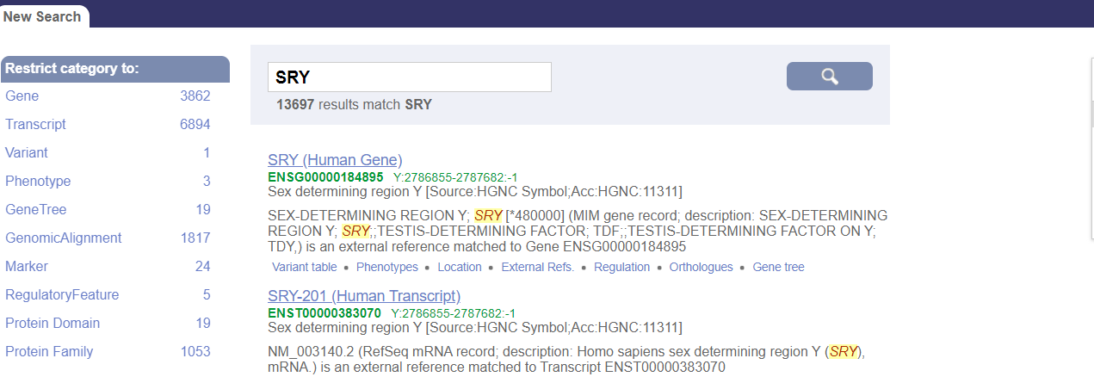

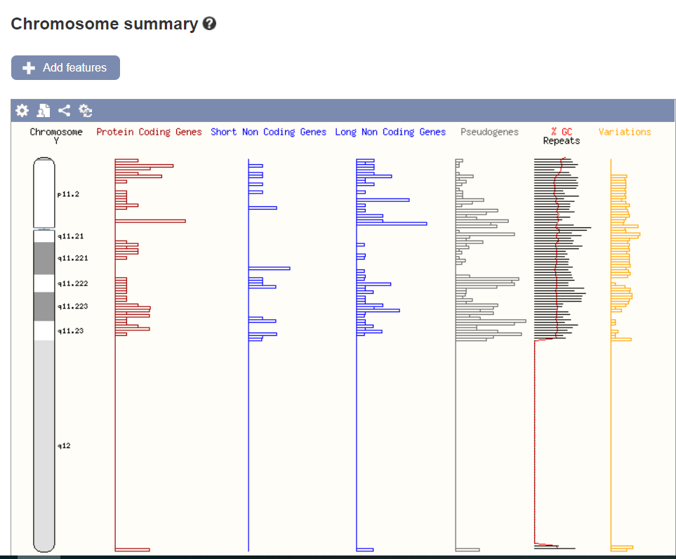

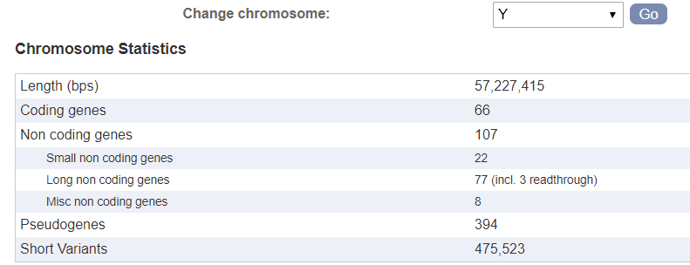

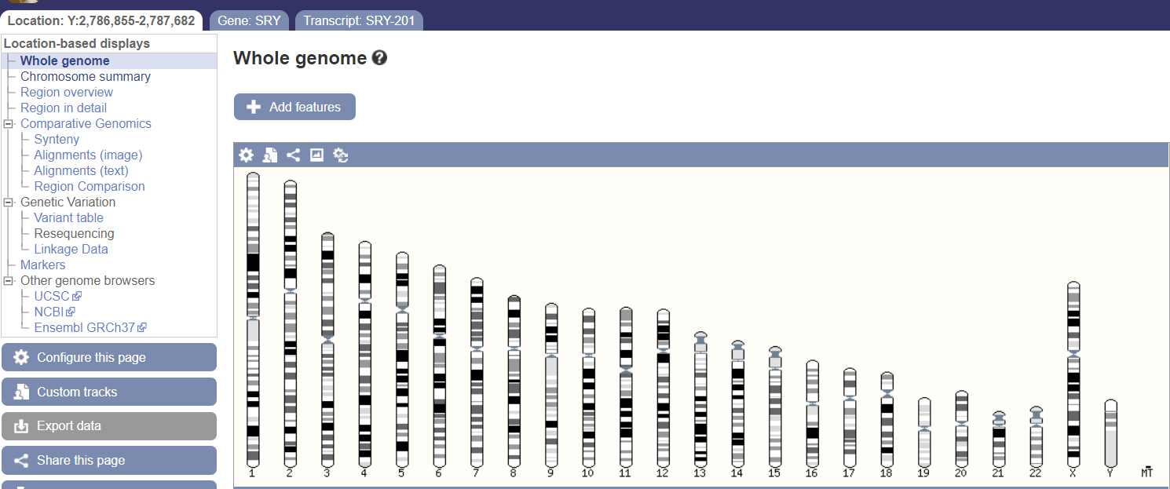

**CHROMOSOME SOX3:**

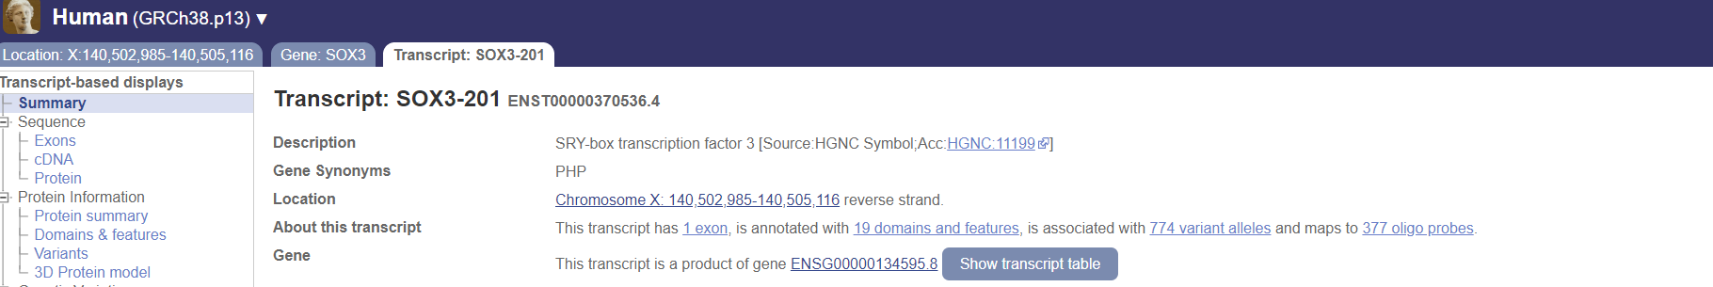

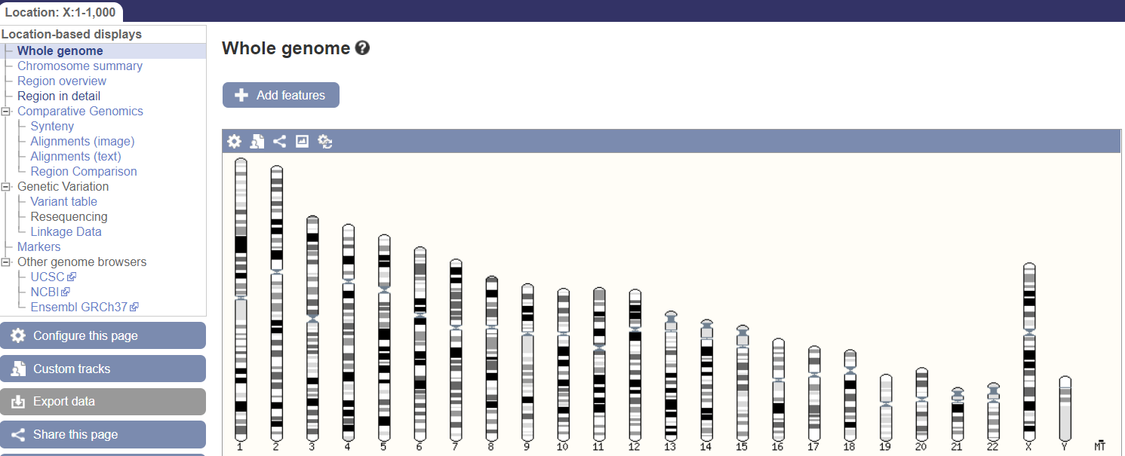

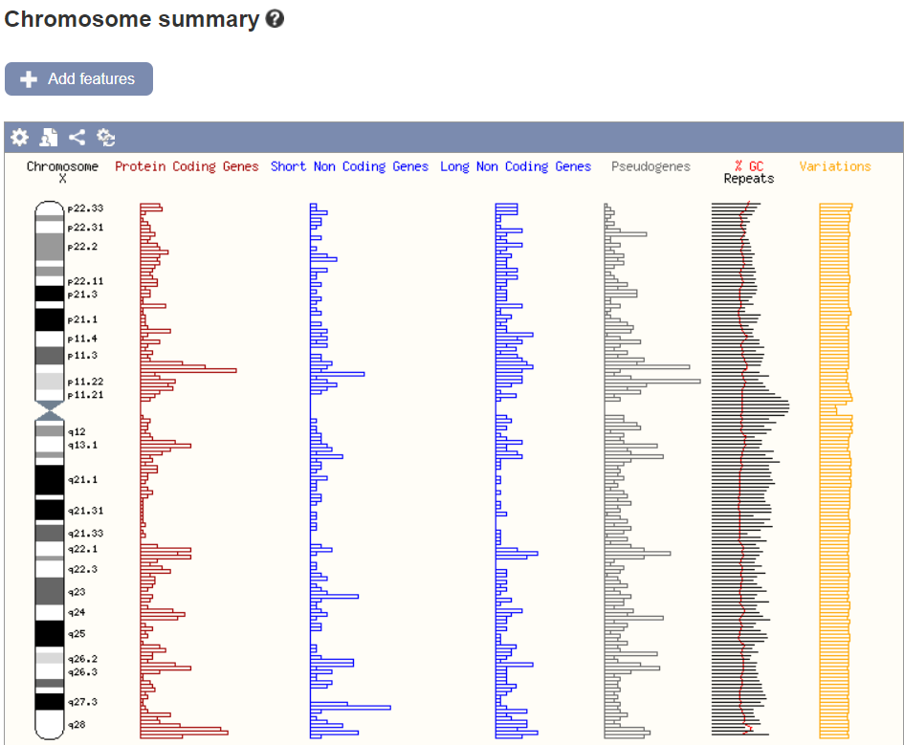

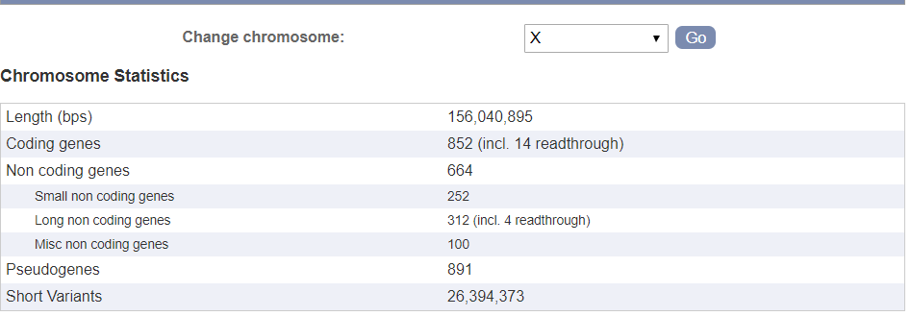

**RESULT:**

[**SRY**](https://www.ncbi.nlm.nih.gov/gtr/genes/6736) (sex determining region Y) that intronless gene encodes a transcription factor that is a member of the high mobility group box family of DNA-binding proteins. This protein is the testis-determining factor which initiates male sex determination. Mutations in this gene give rise to XY females with gonadal dysgenesis (Swyer syndrome); translocation of part of the Y chromosome containing this gene to the X chromosome causes XX male syndrome.

**SOX3** gene encodes a member of the SOX (SRY-related HMG-box) family of transcription factors involved in the regulation of embryonic development and in the determination of the cell fate. The encoded protein may act as a transcriptional regulator after forming a protein complex with other proteins. Mutations in this gene have been associated with X-linked cognitive disability with growth hormone deficiency.